Project Design Phase-II
Technology Stack (Architecture & Stack)

Date | 2 February 2026
Team ID | LTVIP2026TMIDS65523
Project Name | Gemini Historical Artifact Description
Maximum Marks | 4 Marks

Technical Architecture:
The Deliverable shall include the architectural diagram as below and the information as per the table1 & table 2
Example:
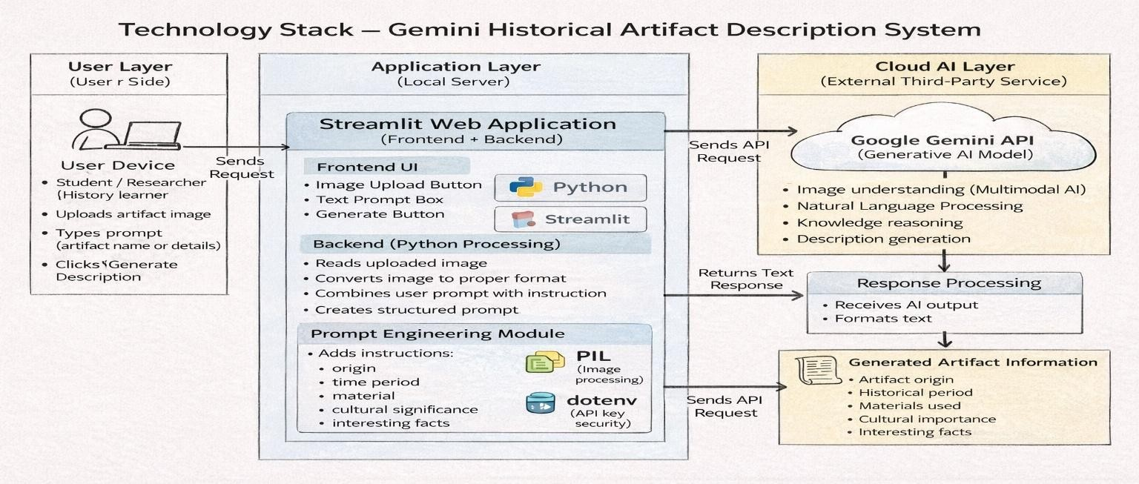
Guidelines:
- Include all main components:
Show every part of the system: User (student), Web Application (Streamlit), Backend (Python), and AI model
(Gemini API).
- Separate Local and Cloud clearly:
  - Local → Streamlit app + Python processing (your laptop/server)
  - Cloud → Google Gemini AI (external service)
- Show external API connection:
Draw an arrow from your application to the Gemini API to represent sending image + text prompt and receiving generated description.
- Show data flow direction:
Use arrows to explain the process:
Upload Image → Processing → AI Model → Response → Display Result.
- Include data storage (if used):
Mention where temporary images, prompts, or results are stored (local memory / session state).
- Mention AI model usage:
Clearly indicate the system communicates with a Machine Learning model (Gemini) for:
  - image understanding
  - natural language generation

- Explain input and output:
  - Input → artifact image + user text prompt
  - Output → historical description (origin, period, materials, facts)
- Keep diagram simple:
Do NOT draw too many boxes. Only important blocks:
User → Web App → Python Processing → Gemini API → Result
Table-1 : Components & Technologies:
S.No | Component | Description | Technology
1. | User Interface | User uploads artifact image and enters prompt through web page. | Streamlit Web UI (Python), HTML, CSS.
2. | Application Logic-1 | Handles image upload, validation, and preprocessing. | Python (Streamlit + PIL library).
3. | Application Logic-2 | Converts image into suitable format and prepares input prompt. | Python Image Processing & Prompt Engineering.
4. | Application Logic-3 | Sends request to AI model and receives generated description. | Google Generative AI SDK (Gemini API).
5. | Database | Temporary storage of session data and prompts. | Streamlit Session State / Local Memory (No permanent DB used).
6. | Cloud Database | Not required — system generates response dynamically. | Not Applicable (Real-time AI response).
7. | File Storage | Stores uploaded artifact images temporarily. | Local File System / RAM (Temporary Storage).
8. | External API-1 | AI model used to generate artifact description. | Google Gemini Pro Vision API.
9. | External API-2 | API key authentication and request handling. | Google AI Studio API Key Service.
10. | Machine Learning Model | Understands artifact image and generates historical explanation. | Gemini Multimodal Generative AI Model.
11. | Infrastructure (Server / Cloud) | Application runs locally and connects to cloud AI service. | Local System (Python environment) + Google Cloud AI Service.

Table-2: Application Characteristics:

S.No | Characteristics | Description | Technology
1. | Open-Source Frameworks | The application is developed using open-source Python libraries for UI, image handling, and API communication. It allows easy development and modification without license cost. | Python, Streamlit, Pillow (PIL), Requests, dotenv.
2. | Security Implementations | The system protects API access using a private API key stored in environment variables. Only authorized requests are allowed to communicate with the AI model. User data is not permanently stored. | Google API Key Authentication, .env file, HTTPS secure connection.
3. | Scalable Architecture | The application follows a lightweight clientserver architecture. The frontend (Streamlit UI) runs locally while heavy processing is handled by the cloud-based Gemini AI model, allowing multiple users without heavy local hardware. | Google API Key Authentication, .env file, HTTPS secure connection.
4. | Availability | The AI service runs on Google Cloud infrastructure, so the system remains available whenever internet connection exists. No local server dependency for AI computation. | Google Cloud AI Services (High  Availability Cloud Servers).

